AISSCE-PRACTICAL EXAMINATION 2025-26
CLASS: XII
SUBJECT: COMPUTER SCIENCE (083)

SET 1
Time Allowed: 3 Hrs Maximum Marks : 30
1. | Write a menu driven Python program to perform following operations into csv file book.csv.  - Add New Book  - Show All Books  - Search Book  - Exit  The csv file book.csv contains [bookno,bname,author,price] | [8]
2. | Answer the questions (a) and (b) on the basis of the following tables STORE and ITEM.  TABLE STORE  SNo SName Area  S01 ABC Computronics GK II  S02 All Infotech Media CP  S03 Tech Shoppe Nehru Place  S04 Geeks Techno Soft Nehru Place  S05 Hitech Store CP  TABLE ITEM  INo IName Price SNo  T01 Mother Board 12000 S01  T02 Hard Disk 5000 S01  T03 KeyBoard 500 S02  T04 Mouse 300 S01  T05 Mother Board 13000 S02  T06 KeyBoard 400 S03  T07 LCD 6000 S04  T08 LCD 5500 S05  T09 Mouse 350 S05  T10 Hard Disk 4500 S03  - Write the SQL queries (i) to (iii):  (i) To display IName and Price of all the items in ascending order of their Price.  (ii) To display Minimum and maximum Price of each IName from the table ITEM.  (iii) To display IName, Price of all items and their respective SName where they are available.  - Write the output of the following SQL commands (i) to (ii):  (i) SELECT Area, COUNT (*) FROM STORE GROUP BY Area;  (ii) SELECT COUNT (DISTINCT Area) FROM STORE: | [4]
3. | 8Practical File | [7]
4. | Project – | [8]
5. | Viva-Voce | [3]

AISSCE-PRACTICAL EXAMINATION 2025-26
CLASS: XII
SUBJECT: COMPUTER SCIENCE (083)

SET 2
Time Allowed: 3 Hrs Maximum Marks : 30

1. | Write a menu driven Python program to perform following operations into binary file student.dat  - Add New Student  - Show All Students  - Search Student  - Exit  The binary file student.dat contains [rollno name, percentage] | [8]
2. | Consider the following relation TEACHER and SALARY answer (a) and (b) parts of this question:  TABLE: TEACHER  TABLE: SALARY  - Write the SQL queries (i) to (iii):  (i) To display FIRST_NAME, LAST_NAME and SUBJECT of all teachers of PHYSICS subject  (ii) To display all teachers records in ascending order of LAST_NAME.  (iii) To display the TID, FIRST_NAME and total SALARY of all PGT from the table TEACHER and SALARY, where total salary is calculated as SAL + BONUS.  (b) Obtain the outputs of the following SQL queries based on the data given in tables TEACHER and SALARY.  - Select First_name from TEACHER where LAST_NAME LIKE “%a”;  (ii) Select AVG (Sal) from SALARY GROUP BY DESIGNATION; | [4]
  TID | FIRST_NAME | LAST_NAME | ADDRESS | SUBJECT
  010 | Rohit | Sharma | 83, Lok Vihar | English
  105 | Meeta | Rathi | 842, Rajouri Garden | Physics
  152 | Seema | Verma | 33, Safdarganj | Maths
  215 | Sarad | Singh | 440, Ashok Vihar | Physics
  244 | Manish | Sengupta | 24, New Street | Maths
  300 | Ram | Gupta | 9, Fifth Road | Chemistry
  355 | Heena | Jain | 12, Friends Street | Computer
  TID | SAL | BONUS | DESIGNATION
  010 | 7500 | 1500 | PGT
  105 | 8500 | 1500 | PGT
  152 | 6000 | 1200 | TGT
  215 | 7500 | 1500 | PGT
3. | Practical File | [7]
4. | Project – | [8]
5. | Viva-Voce | [3]

AISSCE-PRACTICAL EXAMINATION 2025-26
CLASS: XII
SUBJECT: COMPUTER SCIENCE (083)

SET 3
Time Allowed: 3 Hrs Maximum Marks : 30
1. | WAP that will accept a list of numbers from the user. From this list add all numbers divisible by 3 into list represented as stack. Make a menu driven Python program to perform PUSH,POP and Display operation on stack.  - PUSH  - POP  - DISPLAY  - EXIT | [8]
2. | Consider the following tables EMPLOYEE and SALGRADE and answer (a) and (b) parts of this question:  TABLE EMPLOYEE  ECODE NAME DESIG SGRADE DOJ DOB  101 Abdul Ahmad EXECUTIVE S03 2003-03-23 1980-01-13  102 Ravi Chander HEAD-IT S02 2010-02-12 1987-07-22  103 John Ken Receptionist S03 2009-06-24 1983-02-24  105 Nazar Ameen GM S02 2006-08-12 1984-03-03  108 Priyam Sen CEO S01 2004-12-29 1982-01-19  TABLE SALGRADE  SGRADE SALARY HRA  S01 56000 18000  S02 32000 12000  S03 24000 8000  - Write the SQL queries (i) to (iii):  (i) To display employee name, salary in descending order of DOJ.  (ii) To display name and designation of those EMPLOYEE whose sgrade is either S02 or S03.  (iii) To display the content of all the EMPLOYEE table, whose DOJ is in between ’2006-02-09’ to ’2009-08-08’.  (b) Give the output of the following SQL queries:  (i) SELECT NAME, SALARY FROM EMPLOYEE , SALGRADE WHERE EMPLOYEE. SGRADE = SALGRADE. SGRADE AND ECODE<103;  (ii) SELECT SGRADE, SALARY+HRA FROM SALGRADE WHERE SGRADE = ‘S02’; | [4]
3. | Practical File | [7]
4. | Project – | [8]
5. | Viva-Voce | [3]

AISSCE-PRACTICAL EXAMINATION 2025-26
CLASS: XII
SUBJECT: COMPUTER SCIENCE (083)

SET 4
Time Allowed: 3 Hrs Maximum Marks : 30
1. | Write a menu drive program to python to implement stack using a list and perform following functions :(The element in stack can be student names or student marks)  - Push  - Pop  - Display  - Exit | [8]
2. | Consider the tables books and issue write SQL command for given statements:  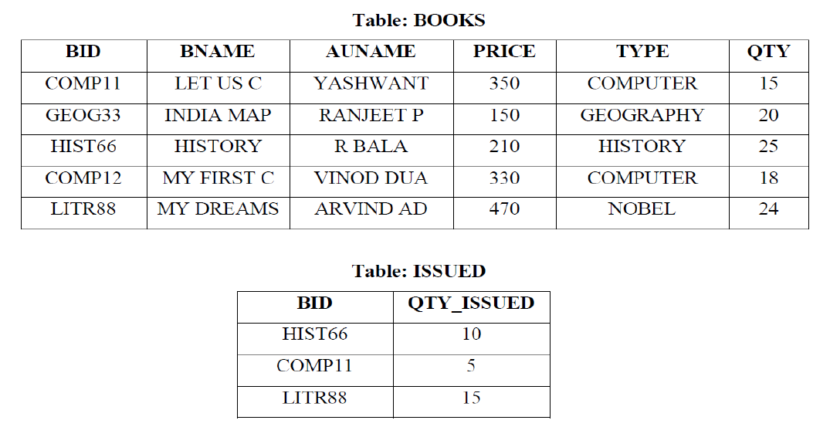  i. Write command to add primary key and foreign key in tables using alter.  ii. Increase the price of all computer books by 70.  iii. Display the book id, book name and quantity issued for all books which have been issued.  iv. Display the book id, book name, author name, quantity issued for all books which price are 200 to 400. | [4]
3. | Practical File | [7]
4. | Project – | [8]
5. | Viva-Voce | [3]

AISSCE-PRACTICAL EXAMINATION 2025-26
CLASS: XII
SUBJECT: COMPUTER SCIENCE (083)

SET 5
Time Allowed: 3 Hrs Maximum Marks : 30
1. | Write a menu drive program to perform the following operations into a binary file shoes.dat. The list contains shoe_id, shoe_name, brand, type,price  1. Add record  2. Display records  3. Search record  4. Exit  The structure of file content is: [s_id, name, brand, type, price] | [8]
2. | Observe the following tables customers and orders and write queries given below:  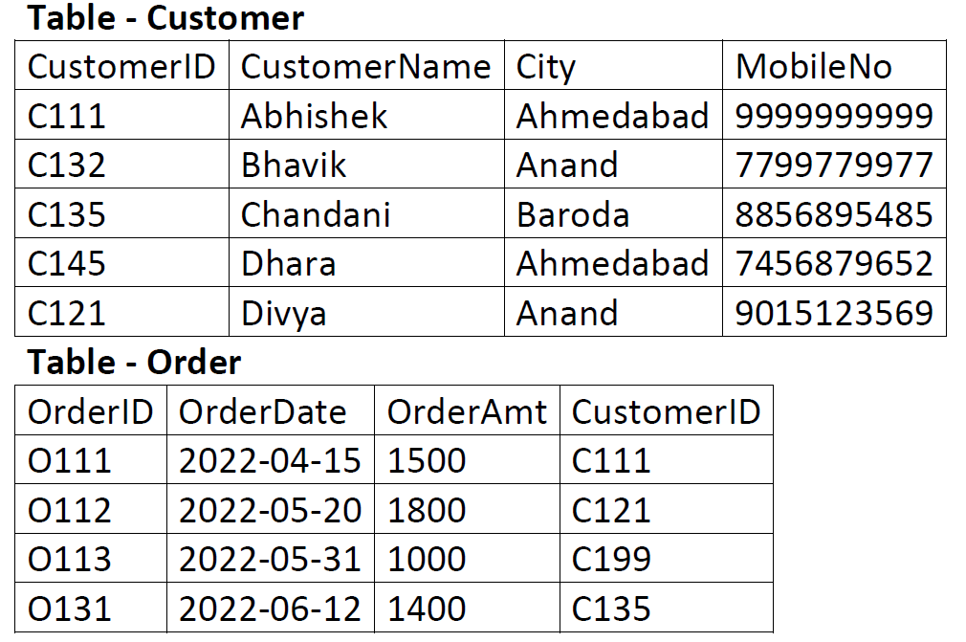  i. Display CustomerID, CustomerName and bill amount for customers belongs to Ahmedabad.  ii. Display the order details in descending order of amount.  iii. Display OrderId, Orderdate , customername and mobileno of customers whose name ends with ‘k’ and name contains letter ‘h’.  iv. Display the sum of order amount for each city. | [4]
3. | Practical File | [7]
4. | Project – | [8]
5. | Viva-Voce | [3]

AISSCE-PRACTICAL EXAMINATION 2025-26
CLASS: XII
SUBJECT: COMPUTER SCIENCE (083)

SET 6
Time Allowed: 3 Hrs Maximum Marks : 30
1. | Consider a record with name, roll and marks of students.  Write 5 records using csv file. Read the same csv file and display the students who have scored more than 90 marks. | [8]
2. | Given the following tables BOOKS and ISSUES. Write queries from (i) to (iv)  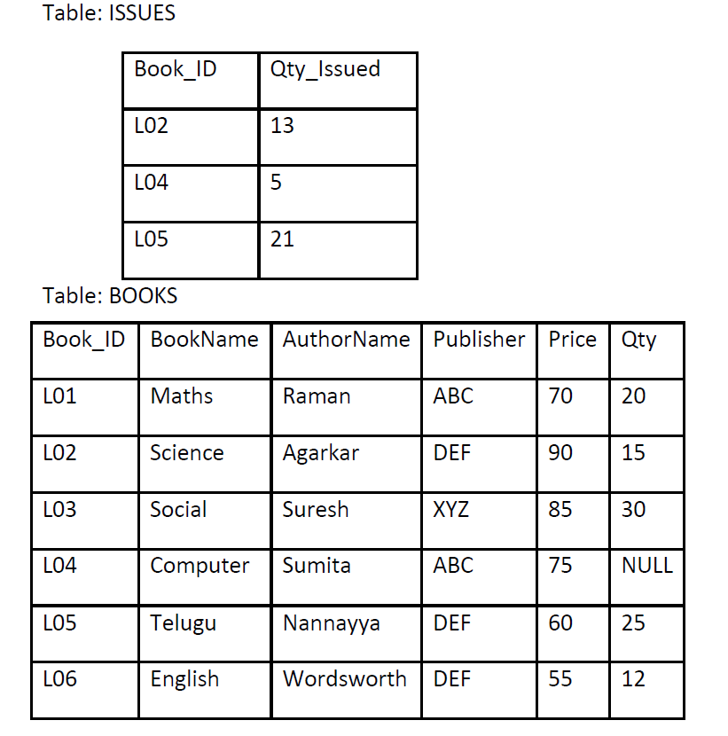  (i)Write a query to display Book_ID, AuthorName and Publisher from table BOOKS so that AuthorName starts with A and the second last character is t.  (ii) DISPLAY the books whose Qty is not NULL  (iii) Display the sum of price for each publisher and the sum() should be displayed only if sum()>100  (iv) Display Book_ID,Qty_Issued,Publisher from the above tables. | [4]
3. | Practical File | [7]
4. | Project – | [8]
5. | Viva-Voce | [3]

