ARMY PUBLIC SCHOOL , DHAULA KUAN
Examination : UT – 2
CLASS : XI SUBJECT : COMPUTER SCIENCE SET : A
Time : 1.5 HRS M.M : 40
General Instructions :
  - All Questions are compulsory
  - Programming language: Python

Q1. list1=[11,42,31,'a',14] . What will the following print: [1/2 x 4=2]
- print(max(a)) Ans error
- list1.reverse() Ans [14, 'a', 31, 42, 11]
- del list[2] Ans [14, 'a', 42, 11]
- list1[:2:-2] Ans [14]

Q2. [1/2*6=3]
Find the output of the following statements:
- _,_, _ = (3.3, 4.1, 2.2)  print(_)  Ans 3.3 | - x = (3.3, 3.3, 4.1, 4.1, 2.2, 2.2)  print(x.index(3.3))  Ans 0
x = (3.3, 3.3, 4.1, 4.1, 2.2, 2.2)  print(x[0::2] == x[1::2])  Ans True | (d)  _,_ = (3.3, 4.1, 2.2)  print(_)  Ans Error
(e)  a="Hello"  b=list(a)  c=tuple(b)  print(c)  Ans ('H', 'e', 'l', 'l', 'o') | (f)  x=(2,1,(4,45,6,78),67,(89))  print(len(x))  Ans 5

Q3. If t is (1, 2, 3)

what is the meaning of t [1:2] = 4 and t [1:1] = 4? [1/2]
Ans This will produce an error: TypeError: 'tuple' object does not support item assignment

Q4. Give answers for the following: [1/2x3=1.5]
- In Boolean Algebra , A.1= ---A--------
- 2.7 GB= 2²⁰*2.7…………….. Kilobytes
- 1 TB=…2²⁰…………MB

Q5. Given the lists [1+1=2]
list=['Red','Green','Magenta','Blue','Cyan','Yellow']
Write output of:
- print(list[-6:-2]) b) print(L[:2:-2])
Ans (a) ['Red ', 'Green', 'Magenta', 'Blue'] (b) ['Yellow', 'Blue']

Q6 is ASSERTION AND REASONING based question. [1]
Mark the correct choice as
A) Both A and R are true and R is the correct explanation for A
B) Both A and R are true and R is not the correct explanation for A
C) A is True but R is False
D) A is false but R is True
Q6. Assertion: An operating system is a system software.
Reasoning: The Software that controls internal computer operation, is called system software.

Q7. Convert the following number systems as specified : [1x4=4 ]
- (10011001)2= (?)16
- (A13B)16 = (?)8
- (242.20)10=( )8
- (1100.010)2 = ( )10

Q8. Differentiate between the following with syntax and one example each : [2x3=6]
- del and pop()
- index() and find()
- reverse() and sort()
Ans (a) del - To remove items by index or slice (range)to delete multiple elements by their position
The pop() method removes the item at the given index from the list and returns the removed item.
(b) find() produces -1 as output if it is unable to find the substring, whereas index() throws a ValueError exception.
(c) sort() method accepts a reverse parameter as an optional argument.
reverse = it print the list in the reverse order not arranging.

Q9. Differentiate between the following [2]
- Utility software and Application Software
- Interpreter and Compiler
Ans (a) Utility software is a program specifically designed to help manage and tune system or application software. It is used to support the computer infrastructure - in contrast to application software, which is aimed at directly performing tasks that benefit ordinary users.
(b) Compiler: A compiler translates code from a high-level programming language (like Python, JavaScript or Go) into machine code before the program runs. Interpreter: An interpreter translates code written in a high-level programming language into machine code line-by-line as the code runs.

Q9. Draw the logic circuit diagram and truth table for the following Boolean expression:[2]
(ZX+Y’)(XY+Z’)

Q10. Prove the complementarity law of Boolean algebra with the help of truth table [2]

Ans AA' = 0, A+A' = 1
Q11. Write Boolean expression of the given logical gate? [2]

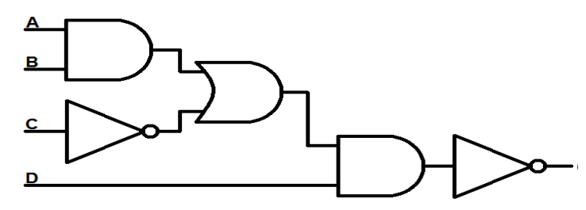
Ans ((a.b)+c’).d)’

Q12.(a) [2]
tuple1 = (11, 22, 33, 44, 55 ,66)
list1 =list(tuple1)
new_list = []
for i in list1:
if i%2==0:
new_list.append(i)
new_tuple = tuple(new_list)
print(new_tuple)

Ans (22, 44, 66)

(b) WAP to calculate the mean of the odd numbers of the tuple . [2]

Q13 Write a Python program in Python to find and display the sum of all the values which are ending with 3 from a list. [2]
Ans
my_list = [13, 23, 33, 43, 53, 63, 73, 83, 93, 103]
sum = 0
for i in my_list:
if i % 10 == 3:
sum += i
print("The sum of all values ending with 3 is:", sum)

Q14. WAP to check entered no is Armstrong no or not. [2]

Q15. The record of a student (Name, Roll No.,Marks in five subjects and percentage of
marks) is stored in the following list:
Result = ['Reema','B-57',[86,56,89,45,68],83.5] [4]
Write Python statements to retrieve the following information from the list Result.
a) Percentage of the student
b) Marks in the third subject
c) Minimum marks of the student
d) Change the name of the student from ‘Reema’ to ‘Sheena’

