ARMY PUBLIC SCHOOL , DHAULA KUAN
Examination : UT – 2
CLASS : XI SET : A SUBJECT : COMPUTER SCIENCE
Time : 1.5 HRS M.M : 40
General Instructions :
  - All Questions are compulsory
  - Programming language: Python

Q1. list1=[11,42,31,'a',14] . What will the following print: [1/2 x 4=2]
- print(max(a))
- list1.reverse()
- del list[2]
- list1[:2:-2]

Q2. [1/2*6=3]
Find the output of the following statements:
- _,_, _ = (3.3, 4.1, 2.2)  print(_) | - x = (3.3, 3.3, 4.1, 4.1, 2.2, 2.2)  print(x.index(3.3))
x = (3.3, 3.3, 4.1, 4.1, 2.2, 2.2)  print(x[0::2] == x[1::2]) | (d)  _,_ = (3.3, 4.1, 2.2)  print(_)
(e)  a="Hello"  b=list(a)  c=tuple(b)  print(c) | (f)  x=(2,1,(4,45,6,78),67,(89))  print(len(x))

Q3. If t is (1, 2, 3)

what is the meaning of t [1:2] = 4 and t [1:1] = 4? [1/2]

Q4. Give answers for the following: [1/2x3=1.5]
- In Boolean Algebra , A.1= -----------
- 2.7 GB= …………….. Kilobytes
- 1 TB=……………MB

Q5. Given the lists [1+1=2]
list=['Red','Green','Magenta','Blue','Cyan','Yellow']
Write output of:
- print(list[-6:-2]) b) print(L[:2:-2])

Q6 is ASSERTION AND REASONING based question. [1]
Mark the correct choice as
A) Both A and R are true and R is the correct explanation for A
B) Both A and R are true and R is not the correct explanation for A
C) A is True but R is False
D) A is false but R is True
Q6. Assertion: An operating system is a system software.
Reasoning: The Software that controls internal computer operation, is called system software.

Q7. Convert the following number systems as specified : [1x4=4 ]
- (10011001)2= (?)16
- (A13B)16 = (?)8
- (242.20)10=( )8
- (1100.010)2 = ( )10

Q8. Differentiate between the following with syntax and one example each : [2x3=6]
- del and pop()
- index() and find()
- reverse() and sort()

Q9. Differentiate between the following [2]
- Utility software and Application Software
- Interpreter and Compiler

Q9. Draw the logic circuit diagram and truth table for the following Boolean expression:[2]
(ZX+Y’)(XY+Z’)

Q10. Prove the complementarity law of Boolean algebra with the help of truth table [2]

Q11. Write Boolean expression of the given logical gate? [2]

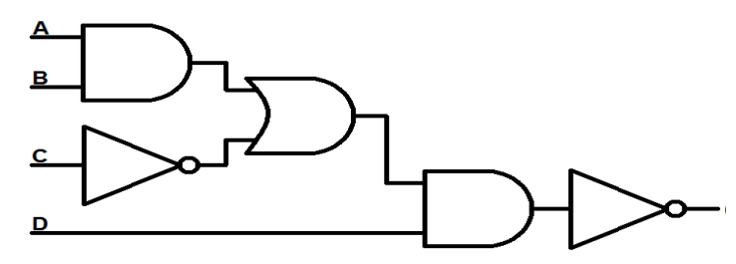

Q12.(a) [2]
tuple1 = (11, 22, 33, 44, 55 ,66)
list1 =list(tuple1)
new_list = []
for i in list1:
if i%2==0:
new_list.append(i)
new_tuple = tuple(new_list)
print(new_tuple)

(b) WAP to calculate the mean of the odd numbers of the tuple . [2]

Q13 Write a Python program in Python to find and display the sum of all the values which are ending with 3 from a list. [2]

Q14. WAP to check entered no is Armstrong no or not. [2]

Q15. The record of a student (Name, Roll No.,Marks in five subjects and percentage of
marks) is stored in the following list:
Result = ['Reema','B-57',[86,56,89,45,68],83.5] [4]
Write Python statements to retrieve the following information from the list Result.
a) Percentage of the student
b) Marks in the third subject
c) Minimum marks of the student
d) Change the name of the student from ‘Reema’ to ‘Sheena’

