Write a program to enter a string and display the string without vowel characters.
Book_Id | Book_name | Author_Name | Publishers | Price | Type | Quantity
C0001 | Fast Cook | Lata Kapoor | EPB | 355 | Cookery | 5
F0001 | The Tears | William Hopkins | First Publ. | 650 | Fiction | 20
T0001 | My First C++ | Brain & Brooke | EPB | 350 | Text | 10
T0002 | C++ Brainworks | A.W.Rossaine | TDH | 350 | Text | 15
F0002 | Thunderbolts | Anna Roberts | First Publ. | 750 | Fiction | 50
- Create the above table Book and insert records into it.
- To display the names and prices of books where price is greater than 400 and quantity is less than 15 in ascending order of their price.
---------------------------------------------------------------------------------------------------------------------------------------
Write a program which will print Fibonacci series till n .
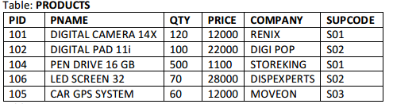
- Create the above table Products and insert records into it.
- To change the price of each product by 500 whose name is staring with ‘D’ alphabet.

Write a program to input a number(N) and find the sum of all numbers till N and it's average. Also to find the sum of all even and odd numbers till N.
Table: SUPPLIERS
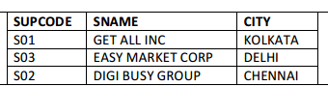
- Create the above table Suppliers and insert records into it.
(ii)To display the details of suppliers whose city name is “KOLKATA” or “DELHI”

A list Num contains the following elements: 3,21,5,6,14,8,14,3
Write a program to interchange the content with next value divisible by 7 so that the resultant array will look like: 3,5,21,6,8,14,3,14
Create a table named as Employee using SQL command of following structure:
FieldName | FieldType | Width | Constraint
No | Int | 3 | Primary key
Name | Character | 20
Salary | Decimal | 7,2 | Default =5000
Area | Character | 10 | Check in A,B or C
Age | Int | 3
Grade | Character | 3 | Not Null
Dept | Character | 5

WAP that reads a line , then counts words and displays how many words are there in a line.
Table : DRESS
DCODE | DESCR | PRICE | MCODE | LAUNCHDATE
101 | Shirt | 515 | M004 | 12-Jan-2008
120 | Formal Shirt | 1213 | M001 | 09-Sep-2007
112 | Frock | 450 | M002 | 06-Jun-2008
119 | Evening Gown | 650 | M003 | 15-Jul-2009
189 | Slacks | 340 | M002 | 09-Jan-2008
107 | Jeans | 770 | M001 | 15-Sep-2009
124 | Jacket | 2050 | M003 | 25-Mar-2009
109 | Fancy Top | 350 | M004 | 31-Dec-2007
(i) Create the above table Dress and insert records into it.
(ii)To modify the schema of table dress by adding an extra attribute namely QTY as integer type.

