ANSWERS
PT1 Examination Class-XI
Computer Science (083) 2025-26
Max Marks: 40 SET A Time: 1 hr 30 min
General Instructions:
Programming Language used is PYTHON. All questions are compulsory.

Q1 _____function is to check the data type of a variable in Python. [1/2]
Ans type()
Q2 Find the invalid identifier(s) from the following: [1/2]
a) MyName b) 2ndName c) true d) My_Name
Ans (b) 2ndName
Q3 Identify declaration of M = ‘Mon’,‘23’,‘Bye’, ’6.5’ [1/2]
Ans tuple
Q4 The input() returns the value as _____type. [1/2]
Ans string
Q5 What will the result of the expression 10 or 0? [1/2]
Ans 10
Q6 Comments in python starts with _____? [1/2]
Ans #
Q7 How will you create a empty string? [1/2]
Ans s=’ ‘
Q8 The following questions 18 is Assertion-Reasoning based, answer the question by choosing one of the following responses: [1/2]
a. Both A and R are true and R is the correct explanation of A.
b. Both A and R are true but R is not the correct explanation of A.
c. A is true but R is false.
d. A is false but R is true.
Q8 A: Python is not a low-level language.
R: It uses English-like words and simple syntax which is very easy to understand to humans.
Ans (a)
Q9 Give output: [1]
print('My' *3 + 'life'+'7')
Ans MyMyMylife7
Q10 Write arithmetic expression using operators in Python [1]
e²-x
Ans math.exp(2)-x
Q11 What is the result of this statement: [1]
10>5 and 7>12 or not 18>3
Ans False
Q12 What will be the output of the following Python code? [1]
>>> 6 * 3 + 4 ** 2 // 5 – 8
Ans 13
Q13 Name two common tools for developing an algorithm. [1]
Ans (a) flow chart (b) pseudocode
Q14 What is the precedence of operators in Python? (The order in which operations are performed) [1]
Ans Parentheses, Exponents, Multiplication/Division, and Addition/Subtraction
Q15 Identify the datatype of the following: [1]
A) False B) “true”
Ans (A) Boolean lieteral (B) string
Q16 Find errors in the following code: [2]
a=integer(input('Enter a number")
a+b=c
print(c)
Ans
a=int(input(“Enter a number"))
c=a+b
print(c)

Q17 What is the difference between ‘=’ and ‘==’? Explain with the help of an example. [2]
Ans = is the assignment operator, while == is the equality comparison operator. = assigns a value to a variable, while == checks if two values are equal.
e.g. a=3 , b==3
Q18 What is the difference between an immutable and mutable data type? [2]
Ans Immutable types cannot be changed after creation, while mutable types can.
Q19 Write a flowchart to calculate the area of rectangle. [2]
Ans
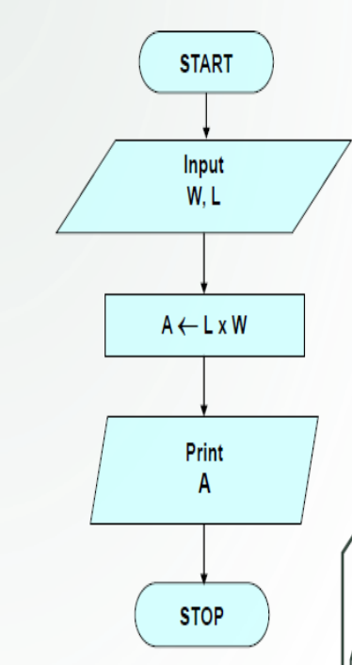

Q20 Find Output: [2]
a,b,c=1,1,2
d=a+b
e=1.0
f=1.0
g=2.0
h=e+f
print(c==d)
print(g==h)
print(g is h)
print(d,h)
Ans
True
True
False
2 2.0
Q21 What is token? Write name of all tokens? [2]
Ans A token is a sequence of characters that represents a specific element in the program, such as a keyword, variable, operator, or punctuation symbol.
Q22 Write a Python program that takes two numbers as input from the user and calculates their sum,difference and multiplication [2]
Ans
A=int(input(‘enter no1’))
B=int(input(‘enter no2’))
print(A+B)
print(A-B)
print(A*B)

